Design Thinking for Human Interaction with Flexible Electronics

Mitsuhiko Nagata, Ph.D.

*Products Development Department, Technology Headquaters, Azbil Corporation, Japan*

[m.nagata.yx@azbil.com](mailto:m.nagata.yx@azbil.com)

*Abstract***— With increasing demand of better human-machine interaction with electronic devices, a flexible form factor in these devices is key for transparency in connection between human and machine. A variety of new approaches for human-machine interaction are available. These include voice, gesture, eye motion, brain wave and so on. Flexible electronics technologies could be key to enhance interaction with the human. To achieve a better intuitional connection, a design thinking approach is essential. This paper will review key factors to adopt this design thinking approach for flexible electronics.**

1. INTRODUCTION

Human interaction with personal computers (PC) has traditionally been mainly with keyboard typing and mouse action. Users needed to learn how to operate a computer in the beginning by instruction manuals. Then the first smart phone was developed in 2007. Interaction with this new device was intuitional and the complicated instruction manuals were discarded. Users adapted well to these new devices, because of the new interface technologies, which were developed based on a design-thinking-approach (DTA). For interaction with the first generation model, it was required to touch a screen with our fingers. Then came the second generation, which utilized voice recognition, and the latest is with image recognition.

Users still need to carry these mobile devices in bags or pockets and daily maintenance is required, such as battery charging, along with periodical update of software.. Users accept this type of daily tasks because smart phones have drastically changed our daily lives to enhance communication with others. So, increasingly there is growing demand for a more convenient way of carrying mobile devices, power charging, and a better way of human-machine interaction. Flexible electronics technologies could be a key for improved interaction between devices and humans because these technologies are well matched with organic materials. In addition to use of these devices for human communications, vital sensing and/or monitoring devices could also be implemented for better daily usage.

1. DESIGN THINKING

Tim Brown, Executive Chair of IDEO says “Design thinking is a human-centered approach to innovation that draws from the designer’s toolkit to integrate the needs of people, the possibilities of technology, and the requirements for business success”. Research and development personnel and designers are similar in a sense that they create the way organizations develop products, services, processes, and strategy.

The five stages of design thinking are follows;

Empathize—research your users' needs. Define—state your users' needs and problems. Ideate—challenge assumptions and create ideas. Prototype—start to create solutions.

Test—try your solutions out.

By using DTA, decisions can be made based on what users (customers) really want instead of relying only on historical data or making risky bets based on instinct instead of evidence

[1] as illustrated in Fig. 1.

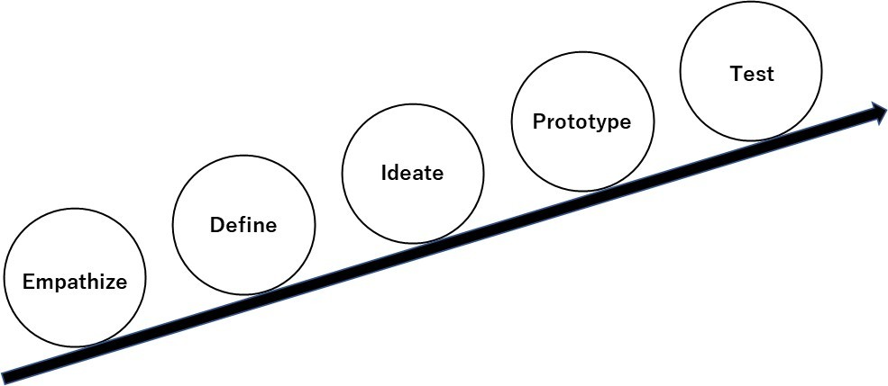

Fig. 1 Five steps outlining the flow of the DTA (by IDEO).

1. FLEXIBLE ELECTRONICS APPROACH

A number of studies have been conducted with flexible electronics technologies that can provide a better interface between devices and human. Liu *et al.* presented a carbon-based formulation that is suitable for stencil printing on textiles to fabricate stretch and flex sensors for the detection of human joint movement [2]. AlMohimeed *et al.* presented a wearable ultrasonic sensor made of a polyvinylidene fluoride film to measure skeletal muscle contractile properties as a quantitative assessment tool [3]. Ozgio *et al.* presented non-intrusive (“wear and forget”) patch platform for patient monitoring [4]. Diotallevi *et al.* presented the evaluation of the degradation of the radiation gain of on-skin UHF antennas in common gestures by a combined mechanical-electromagnetic model [5]. Beeby *et al.* presented research on printed piezoelectric films, ferroelectret fabrics, spray coated solar cells, fabric-based inductive wireless power transfer and textile-based super capacitors [6]. An example of a textile-based power module is shown in Fig. 2.

2022 IEEE International Flexible Electronics Technology Conference (IFETC) | 978-1-6654-6968-5/22/$31.00 ©2022 IEEE | DOI: 10.1109/IFETC53656.2022.9948482

978-1-6654-6968-5/22/$31.00 ©2022 IEEE

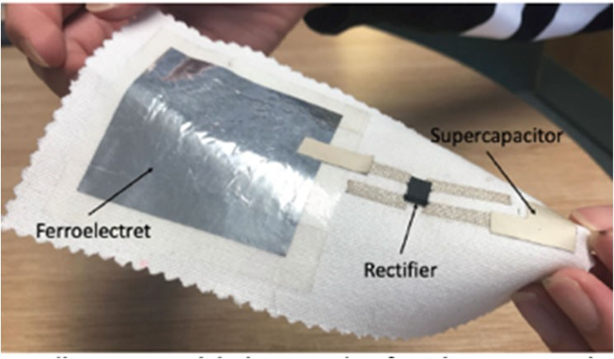

Fig. 2 Textile power module by Beeby *et al* [6]*.*.

Yi *et al.* presented a fully printed strain sensor consisting of carbon ink coating layer and interdigitated shape silver in electrodes solidified on a polyimide substrate [7]. Karanassios reviewed trends on sensor research, development and commercialization. Also sensor-powering schemes, ranging from energy scavenging and harvesting to self-powering and power-management, were outlined in [8].

1. DISCUSSION

According to Watanabe, “The design of the user interface becomes important, and what is the ideal of the user interface? It is actually the way tools should be, like in the Stone Age. When you use a pencil, you don't always think about how comfortable the pencil is to use. The pencil becomes transparent and does not come up in our consciousness, or we might say that it becomes a part of our human system. We believe that the ideal interface design is to be transparent as well” [8].

Smartphones are still something special to carry. Styles, functions and usability are key factors for users to select. With increasing functions, users may need to learn how to use them by tutorials (no more instruction manuals). But those phones seem to set a new culture of lifestyle and they will become “transparent” soon.

There are two aspects to consider when devices interface with the human.

1. *Comfortable communication interaction*

Typing, flicking and pinching are common way of interacting with smart phones now. Voice recognition has been around but it is not well adopted because communication with voice is modal and requires step-by-step interaction which takes time, and also voice is open to public-type communication and normally users do not want others to listen. So, interface with fingers still remains a natural choice. Flexible and foldable keyboard interfaces which could be wearable on wrists would pose a good medium. Wearable glasses would be a good way for information display with combination with smart phones. Gestures or dancing movement detection could be used for communication purposes. But users are not used to such gestures. Watches already interface with smartphones, but typing from watch window is not practical.

Developing interfaces for disabled or handicapped people needs to be considered for equal opportunity. For such applications, operation by foot, gesture type, eye tracking, skin move and brain wave communication will be promising future interactive technologies with flexible electronics.

1. *Transparent vital data communication*

Vital data, such as blood pressure, heart beat, oxygen saturation, and excretion monitoring are troublesome and uncomfortable for disabled people and patients. So wear and forget-type intrusive or non-intrusive patch-type vital monitors are very helpful, especially with self-powered capability. Microchip implant under skin could be a practical application possibly with flexible electronics technologies. Personal IDs can be embedded to communicate with external devices using inductive wireless power [9]. In such cases, users do not need to communicate with devices.

Meeting Sustainable Development Goals (SDGs) is now required for any kind of activity. Considering environmental protection, such as energy savings, environmental friendly material usage and recycling or disposal methods are mandatory. Wearable devices with textiles may be designed in a way so that recycling of materials can easily be done. Power harvesting from the human body or movement, and flexible solar cells are encouraging technologies for deployment in energy-autonomous devices.

1. CONCLUSIONS

Human behaviour with digital devices is discussed. Flexible electronics technologies will be one of the key technologies for enhanced interactivity. Here, a design-thinking approach is important, taking into account user choice preferences and evidence-based data instead of relying on historical data.

Considering environmental protection, such as energy savings, environmental friendly material usage and recycling or disposal methods are mandatory.

REFERENCES

1. https://designthinking.ideo.com
2. Meijing Liu, et.al, *“Printable Perzoresistive Carbon Formulation for Stretch and Flex Sensors in E-Texitile Applications” in Proc. IEEE FLEPS*, Emerging Applications 1-2, 2019
3. Ibrahim AlMohimeed, et. al, *“Flexible and Wearable Ultrasonic Sensor for Assessment of Skeletal Muscle Contractil Properites” in Proc. IEEE FLEPS*, Emerging Applications 1-4, 2019
4. Dilek Ozgit, et.al, *“Wear and Forge patch for ambient assisted living” in Proc. IEEE FLEPS*, Low-power & Hybrid Systems 3, 2019
5. D. Diotallevi, et.al, *“Radio-Mechanical Model of Epidermal Antenna Stretching during Human Gestures” in Proc. IEEE FLEPS*, Modeling & Simulation 1-5, 2019
6. Stephen Beeby, et.al, *“Energy Harvesting Power Supplies for Electronic Texitiles” in Proc. IEEE FLEPS*, Energy Harvesting & Storage Systems 1-1, 2019
7. Ying Yi, et.al. *“An Inkjet-printed Strain Sensor with a Carbon-Silver- Polyimide Topology” in Proc. IEEE FLEPS*, Energy Harvesting & Storage Systems 1-1, 2019 Poster-32
8. h[ttps://www.n](http://www.ndc.co.jp/polylogue/watanabe-keita-2019/)dc.c[o.jp/polyl](http://www.ndc.co.jp/polylogue/watanabe-keita-2019/)og[ue/watanabe-keita-2019/](http://www.ndc.co.jp/polylogue/watanabe-keita-2019/) (in Japanese)
9. h[ttps://www.b](http://www.bbvaopenmind.com/en/technology/innovation/technology-)bvaope[nmind](http://www.bbvaopenmind.com/en/technology/innovation/technology-).[com/en/technology/innovation/technology-](http://www.bbvaopenmind.com/en/technology/innovation/technology-) under-your-skin